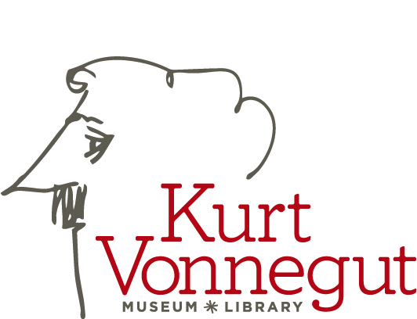

Thank you for your interest in volunteering with the Kurt Vonnegut Museum and Library.
Please complete the following information:

Name _________________________________ Email ________________________________________
Address ___________________________________________________________________________________________
Cell Phone and/or Home Phone _______________________________________________________________________
Profession _________________________________________________________________________________________
Hobbies/Interests ___________________________________________________________________________________

Jobs for which you are interested in volunteering:

Administrative Work (at home or library)
_____ Thank You Notes/Correspondence _____ Fundraising _____ Data Entry

_____ Writing/Editing _____ Marketing ____ Phone Calls

Library Volunteer (Onsite)
_____ Tour Guide _____Gift Shop _____Cleaning _____ Misc. Office Work

__________________________________________________________________________________________________

Lonesome No More Programs in 2018*

Night of Vonnegut – April 13 – 6 to 9:30 pm at Indiana Roof Ballroom
_____ Silent Auction Committee Event Planning Months Prior to April 13 (Monthly Meet 2nd Monday at 11 am)
_____ N of V Help on April 13 (Set Up/Tear Down, Registration, Silent Auction Help, etc.)

_____ In Our Own Voice Mental Health Program _____ Global Beatles Day
May 16 – 6 to 7:30 pm Location TBD June 25 – 6 to 7:30 pm Location TBD

_____ Penrod
September 8 (?) – Various Shifts TBD

Banned Books Week – September 24 to 29 at Various Locations

Noon Reads: Mon _____ Tues _____ Wed _____ Thurs _____ Fri ____

Evening Events: (Times and Locations TBD)
_____ Mon: Nanny Vonnegut Talk _____ Tue: Naked Lunch Film
_____ Wed: Examining Ethics Podcast _____ Thu: Too Much of a Good Thing
_____ Fri: Author Talk (TBD) _____ Sat: Mental Health Youth Program

_____ Monumental Marathon Water Station
November 3 – 7 to 10 am
(More on Back)

(Volunteer Info Continued from Page 1)

VonnegutFest – November 7 to 10 at Various Locations (Most Times TBD)
_____ Wed: Mental Health in Legal Community _____ Thu: LNM Through Faith Communities
_____ Fri: Vonnegut-Themed Get Together _____ Sat 10 am: Breakfast of Champions (YAT)
_____ Sat Noon: So It Goes Journal Readings _____ Sat TBD: Reclaiming Armistice Day
_____ Sat Evening: Evening of Humor

_____ Donor/Volunteer Appreciation Event ____ Living Works SafeTalk Event
December 6, TBD December 8, TBD

Note: Keep in mind these events/times may change, and additional events may be added. Keep an eye out for announcements in the newsletter.

Thank you again for sharing your time, talents, and treasure with KVML. We so appreciate you!

